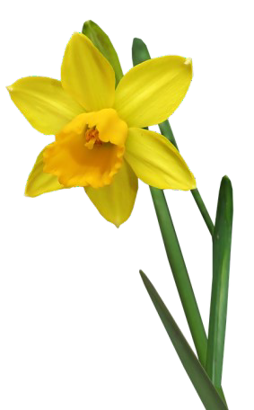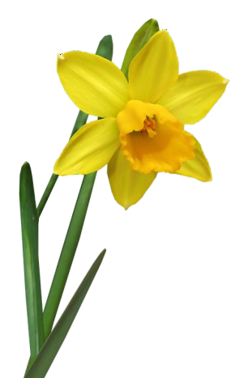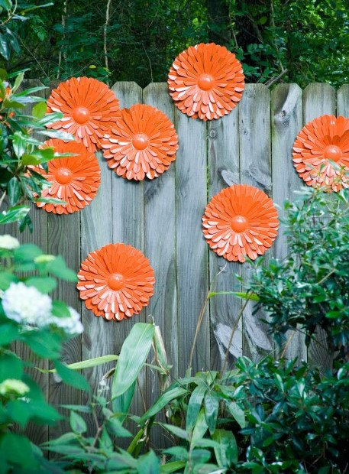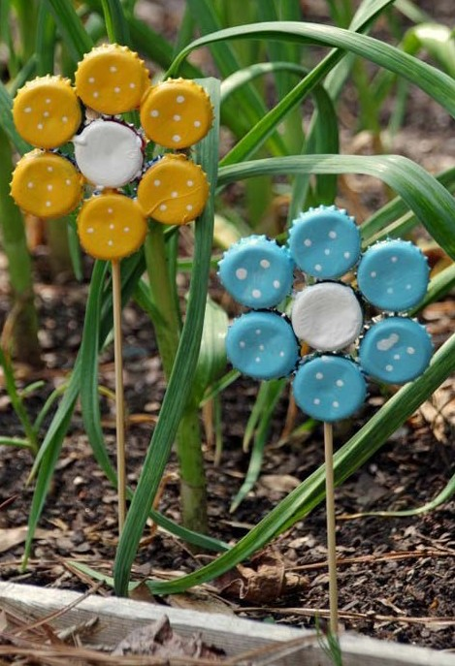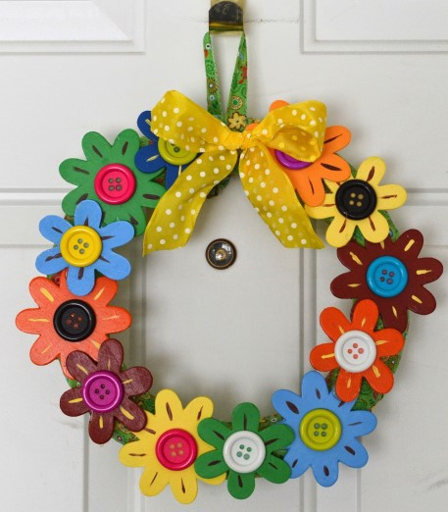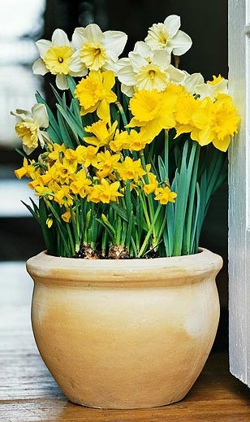Spring Flower Show 2021
Special Lockdown Edition: 'A Spring Village'

WHEN
Saturday 3rd April and for the rest of the Easter Bank Holiday Weekend.

WHAT
Not a normal flower show - not even a virtual flower show like last Autumn
– but an event across the whole village. No competition - just take part
and let's decorate the village to celebrate Spring.

HOW TO TAKE PART
Decorate your windows, house, fence or front garden on a floral theme.
Some ideas—feel free to develop your own:
- Live flowers, bulbs, baskets or pot plants in your front windows
- Drawings, paintings, photos or sculp-
tures in your front windows
- Spring wreaths, swags, hangings, bunting or sculptures on your front door, garden gate or fence
- Add potted plants or sculptures to your front garden
- Children’s drawings and sculpture
particularly welcome
If you intend to decorate your house, windows, fence or garden, let us know by Sunday 21th March if you'd like to be added to a map so that people can find you.
Email (and for enquiries): flowershow@dorchesteronthames.co.uk

Team efforts to decorate our public
spaces would be great!
Please maintain social distancing and combine touring the show with your daily exercise. Please view from public rights of way and don't enter private property unless invited.

