EVIDENCE QUESTIONNAIRE IN SUPPORT OF A CLAIM FOR REGISTRATION OF LAND AS A NEW VILLAGE GREEN
Under section 15 of the COMMONS ACT 2006

DAY’S LOCK MEADOW

In the parish of Dorchester on Thames, South Oxfordshire

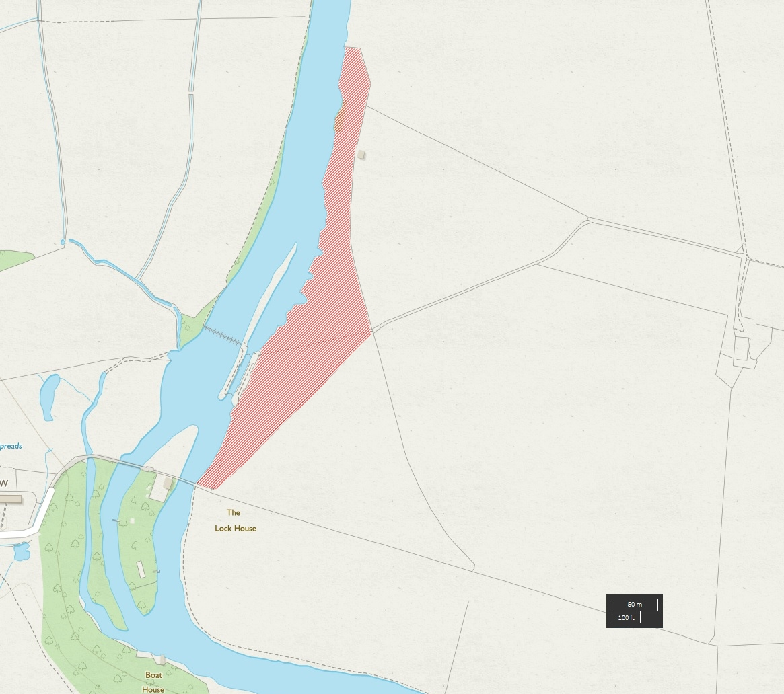
Map A: Land being claimed as a village green

EVIDENCE QUESTIONNAIRE IN SUPPORT OF REGISTRATION AS A NEW GREEN

Name:
Address:
Postcode:
Telephone no:

THE CLAIMED LAND

1. | Address where you were living when you used the land (if different  from above)  (The land in this form means ‘the claimed land’.)
2. | Have you signed alongside ‘Map A’ to confirm it shows the land being claimed as a green?  (Map A is the map showing the claimed land) | Yes / No
3. | By what name, if any,  is the land shown on ‘Map  A’ known?
4. | Has it ever to your  knowledge been known by  any other name? If so, what name?
5. | For how many years have you known the land? | From ................................ to ...........................

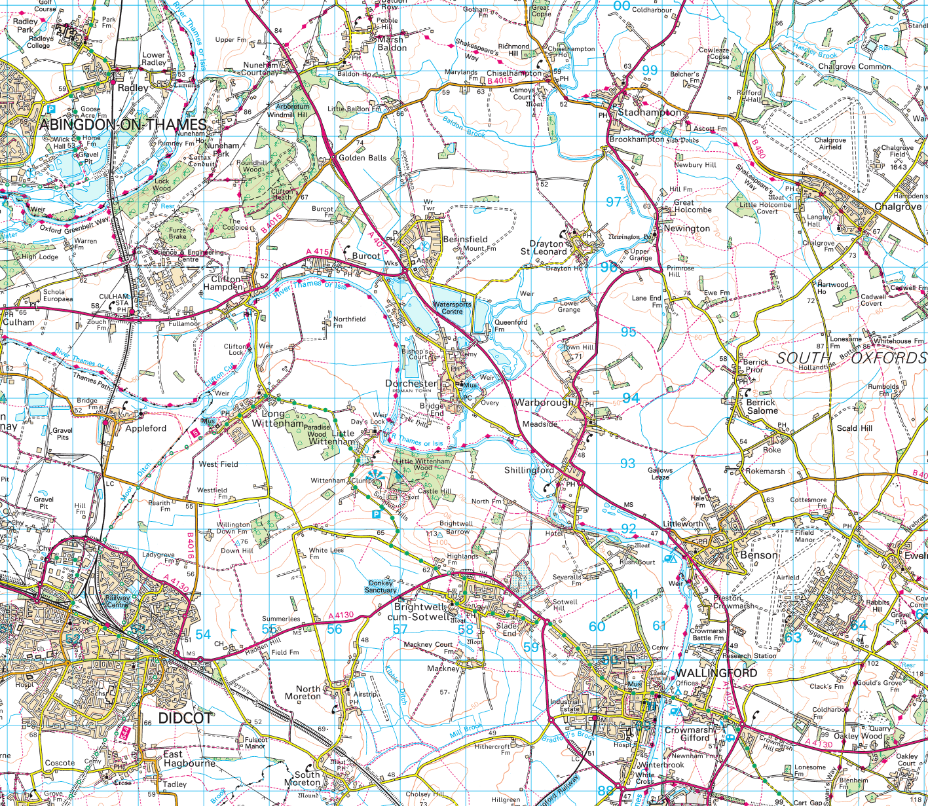
Map B: Locality

LOCALITY/NEIGHBOURHOOD WITHIN A LOCALITY

6. | Does the above map (Map B: locality) include where you live? | Yes / No
7. | Mark the location of your house with an X on  the map above (Map B)
8. | Does your locality or neighbourhood have a  name, if so please include | Yes / No
9. | Do you live within this defined area? | Yes / No
10. | Where do other people who use the land come  from?
11. | This question is trying to establish “locality”, and sometimes it can be based around certain facilities. It also helps to know if there is an organised group which may have been using the site (eg scouts)  What recognisable facilities are available in your locality?  Please tick all boxes that apply and add any OTHER additional matters not covered.

□ School catchment area □ Area policeman
local school □ Doctor’s surgery
□ Residents’ association □ Community activities
□ Community centre □ Neighbourhood watch
□ Local church or place of worship □ A central feature
□ Sports facility □ Scout hut
□ Local shops □ Other (please state)

‘AS OF RIGHT’: HAS USE BEEN WITHOUT PERMISSION, SECRECY OR FORCE?

12. | To your knowledge are there any public paths (ie paths that the public use) crossing the land? | Yes / No
13. | How do/did you gain access to the land?
14. | Do you know who the owner/occupier is now?  Do you know who the owner/occupier was prior to October 2016?  Supply details | Yes / No  Yes / No
15. | Has the current or previous owner/occupier seen you on the land? | Yes / No
16. | What did he/she say? and when was this?
17. | Was permission ever sought by you for specific activities on the land? | Yes / No
18. | If so, from whom and when, and what for?
19. | Did anyone ever give you permission to go onto the land? | Yes / No
20. | If yes, when and for what reason
21. | Have you ever been prevented from using the land? | Yes / No
22. | If yes, what was the reason?
23. | Has any attempt ever been made by notice or fencing or by any other means to prevent or discourage the use being made of the land by  local people? Please provide dates and the wording of any notices and mark their position on Map A.

LAWFUL SPORTS AND PASTIMES : what can you tell us?

24. | Why do you go onto this piece of land?
25. | How often do/did you use the land?
26. | What activities do you use the land for now?
27. | Does your family use the land or have they done so in the past? If so list the activities.
28. | Did you see other people using the land? Were  they from the locality or neighbourhood?
29. | Do you know of any community activities  that take place or have taken place on the  land?
30. | Please list them and state as best you can when and for how long they have taken place
31. | Do you participate in any of them?
32. | Do any organisations use the land for sports or pastimes? If so please specify.
33. | Do any seasonal activities take place on the land?
34. | Please tick all the activities that you have seen taking place on the land. | □ Children playing □ Football  □ Rounders □ Cricket  □ Fishing □ Bird watching  □ Drawing and painting □ Picnicking  □ Dog walking □ Kite flying  □ Team games □ People walking  □ Picking blackberries □ Bonfire parties  □ Community celebrations □ Bicycle riding  □ Fetes □ Canoeing  □ Other (please state)

20 YEARS USE

35. | Which years have you used the land | From ................................ to ...........................
36. | How often did you use the land?
37. | If you still use the land now, how often do you  use it?
38. | During the time you have used the land has the  pattern of use remained the same?  If not please supply details | Yes / No

IS USE CONTINUING AT THE DATE OF APPLICATION

39. | How have you accessed the land? (mark on  Map A)
40. | Is the land enclosed? | Yes / No
41. | Please mark on the map:  - gates (G)  - kissing gates (KG)  - stiles (S)  Please indicate those you use for access by circling them.  Have you ever had your access denied through these access points? Please supply details, if so. | Yes / No

OTHER EVIDENCE

42. | Do you have any photographs or any other  evidence of use of the land by local inhabitants? | Yes / No
43. | Are you willing to lend them to us? | Yes / No
44. | If you have additional information please include below or attach a separate statement. | Yes / No
45. | If you have knowledge of others who may  be in a position to complete an evidence form, would you please write their names and  addresses upon this form. | Yes / No
46. | I have carried on the activities referred to in this questionnaire for years without anybody trying to stop me and I believe the activity should be treated by the law as having a lawful origin
47. | I understand that the evidence form I completed may be used in relation to this application may become public knowledge and I authorise the applicant to disclose this form to anyone reasonably requiring access to this application.
48. | I also understand that this evidence may be presented at a non-statutory inquiry and I authorise the applicant to use this form for that purpose.
49. | Would you be prepared to give oral evidence of your use of the land at a public inquiry? | Yes / No
I certify that to the best of my knowledge and belief, the information I have given in this statement is true.

Signed ............................................ Date ...............................

(Please return this form to Becky Waller)

Any further comments you wish to make (e.g. what does this area mean to you?)

(Feel free to carry on overleaf if you wish)

